CH2: Setting up your python Environment

As we discussed in previous chapter, Python is available for different platform like Windows, Linux and mac. In this section, we will discuss how we can install python and setting up for windows, Linux and mac.

**2.1. Setting up python in Windows.**

Please do the following steps to get the python in your Windows machine (Xp, Windows 7 and Windows 8).

*Step 1: Download Python Installer:*

Open a Web browser and go to http://www.python.org/download/ and click the link for the Windows installer python-XYZ.msi file. XYZ indicates the version you are going to install.

For example click the link and download: <http://www.python.org/ftp/python/2.7.6/python-2.7.6.msi>

*Step2: Install Python*: Run the downloaded file by double-clicking it in. This brings up the Python install wizard, which is really easy to use. Just accept the default settings, wait until the install is finished.

**Step 3: Setting the Path variable:**

Generally python getting installed in C:\python27 and all python executable are live in this folder. Before running python you need to setup the path. To do this, please follow the following steps:

1. Right Click MyComputerIcon -> Click properties -> it will open Control panel.
2. Click Advance System Setting in Left panel, a popup will be displayed.
3. Click Environment variable.
4. Edit path variable and add the python path (“C:python27”)

OR

1. Open command prompt( by typing cmd in run win xp/ search area in win7)
2. In cmd prompt type: path %path%; C:\Python and press Enter.
3. Now type python: It will open Python Terminal in cmd prompt.

The following figure shows that I have opened command prompt, then I go to C:\python directory and type python. Hence it will open the python shell.

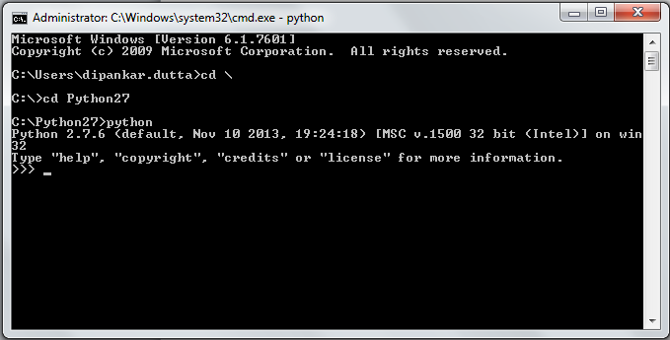

**2.2: Install Python Linux:**

There is a number of ways to install python in Linux. We can use easiest method to install python in different Linux distribution.

**2.2.1 Install python in UBUNTU**: Open terminal and Type:

root#sudo agt-get install python

root#python

>>>

**2.2.2: Install Python in CentOS:** Open terminal and Type:

root#sudo yum install python

root#python

>>>

**2.2.3: Install Python in Fedora:** Open terminal and Type:

Root$sudo yum install python

Root$python

>>>

**2.3 Install Python on Mac**

Recent Macs come with Python installed, but it may be several years out of date. See http://www.python.org/download/mac/ for instructions on getting the current version along with extra tools to support development on the Mac. For older Mac OS's before Mac OS X 10.3 (released in 2003), MacPython is available."

Jack Jansen maintains it and you can have full access to the entire documentation at his Web site - Jack Jansen Website : http://www.cwi.nl/~jack/macpython.html.

Just go to this link and you will find complete installation detail for Mac OS installation